**Applied Data Science**

**Air Quality Analysis and Predication in Tamil Nadu**

|  |  |
| --- | --- |
| **DOMAIN:** | **Applied Data Science** |
| **PROJECT TITLE:** | **Air Quality Analysis and Predication in Tamil Nadu** |
| **TEAM MEMBERS AND REGISTER NUMBER** | **1.GIRIPRASATH S - 420421104020**  **2.GUGAN M - 420421104024**  **3.HEMANTH RAO BK - 420421104027**  **4.JANAKIRAMAN S - 420421104029** |

PHASE_3 : SUBMISSION DOCUMENT

Introduction:

* **Analyzing and predicting air quality in a specific region like Tamil Nadu involves collecting air quality data, preprocessing it, and applying various analytical and predictive techniques. Here's an outline for a document that you can create to detail this process**

Import Libraries:

* Numpy
* Pandas
* Matplotlib
* Seaborn

1. **Dataset Loading and Exploration**:
   * Import necessary libraries.
   * Load the dataset.
   * Explore the dataset's structure and basic statistics.
   * Identify missing values and outliers, if any.
2. **Data Preprocessing**:
   * Handle missing values (impute or remove data as necessary).
   * Address outliers using appropriate techniques.
   * Convert categorical features into numerical representations (if applicable).
   * Standardize or normalize numerical features.
3. **Data Analysis**:
   * Explore the distribution of electricity prices.
   * Analyze temporal patterns (e.g., hourly, daily, monthly trends).
   * Examine the correlation between variables.
   * Visualize the data to gain insights.
4. **Conclusion:**

* Summarize the findings, discuss the model's performance, and provide recommendations or future work.

**Program:**

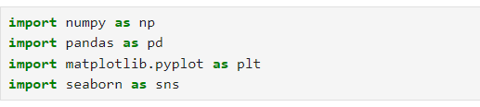



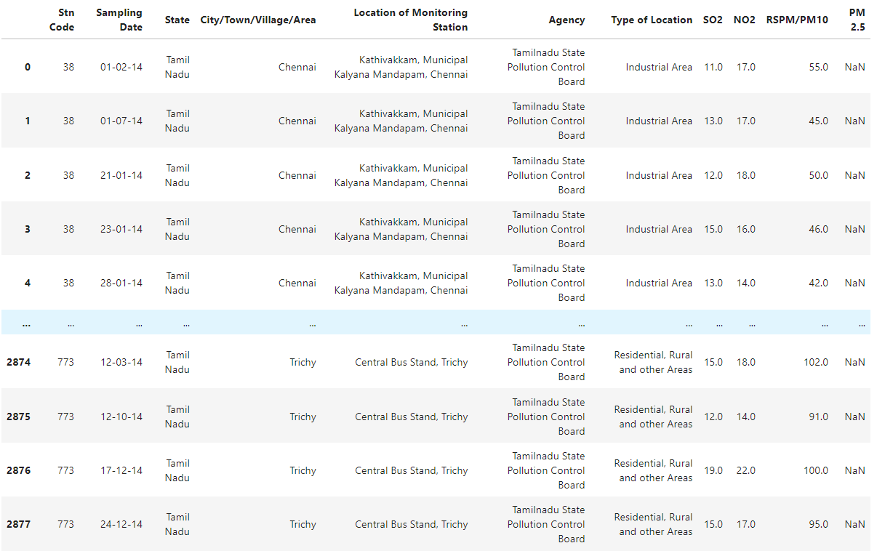

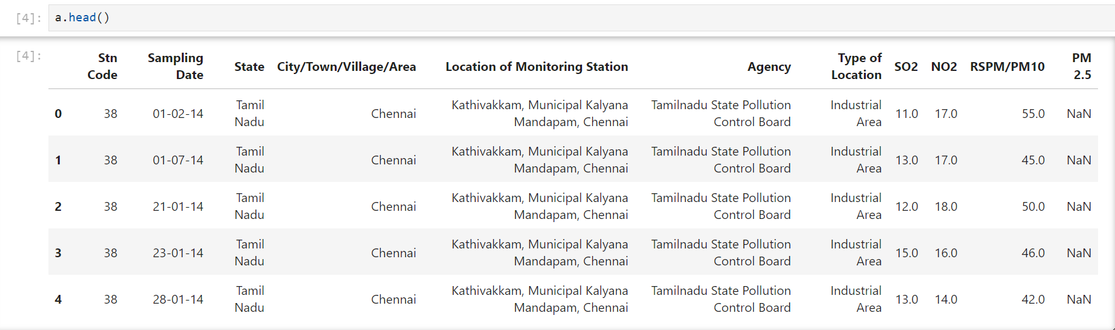

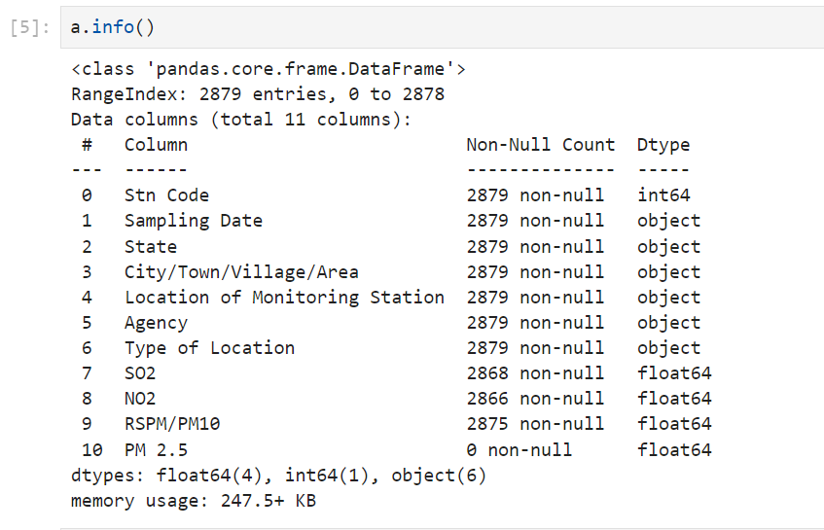

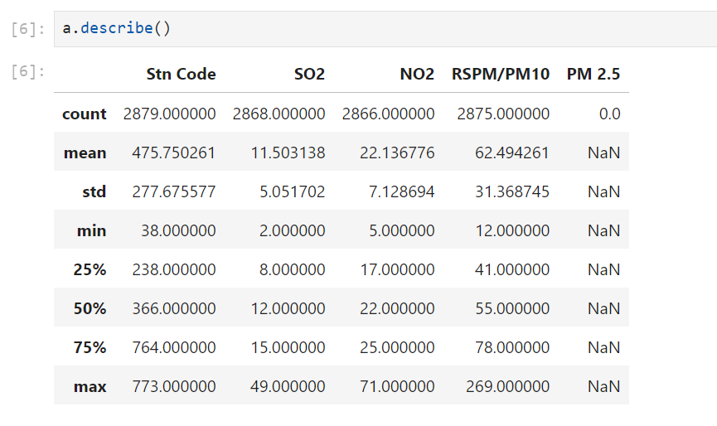

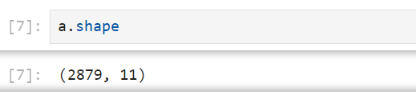

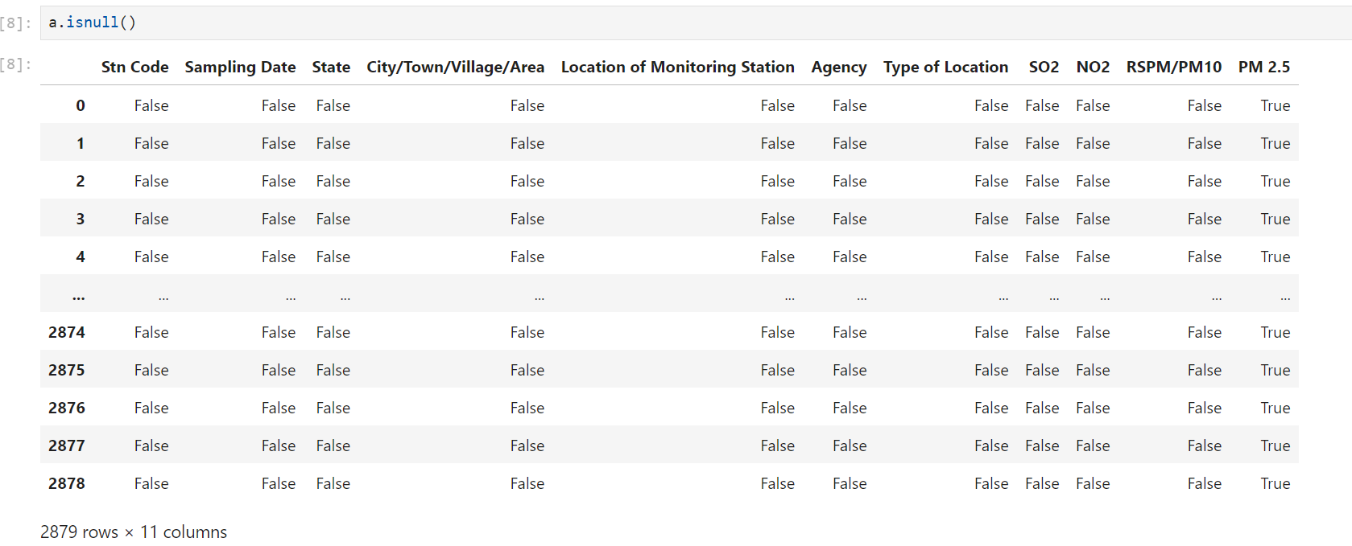

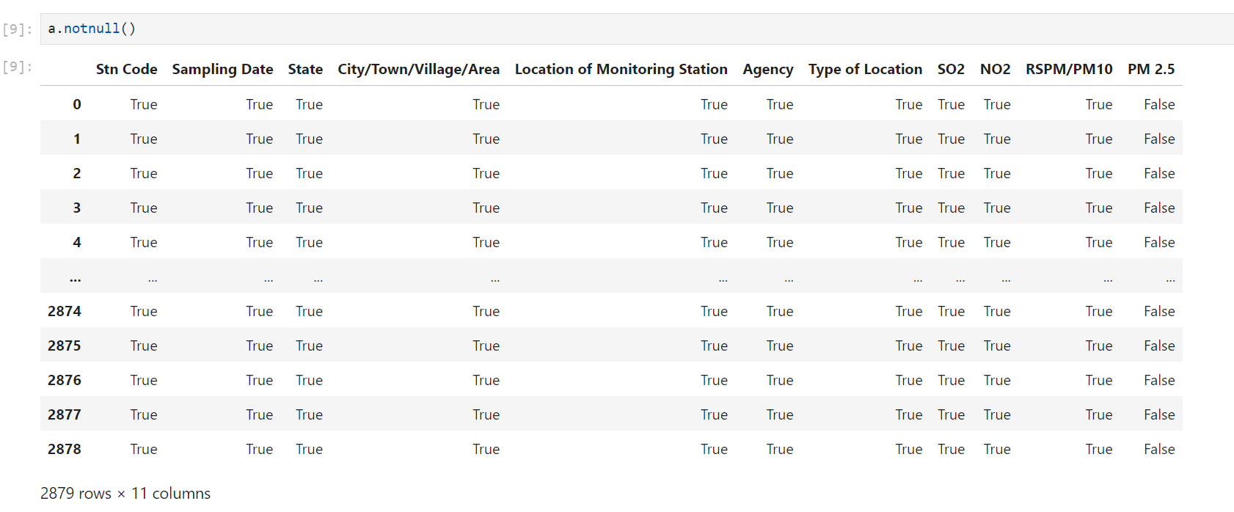



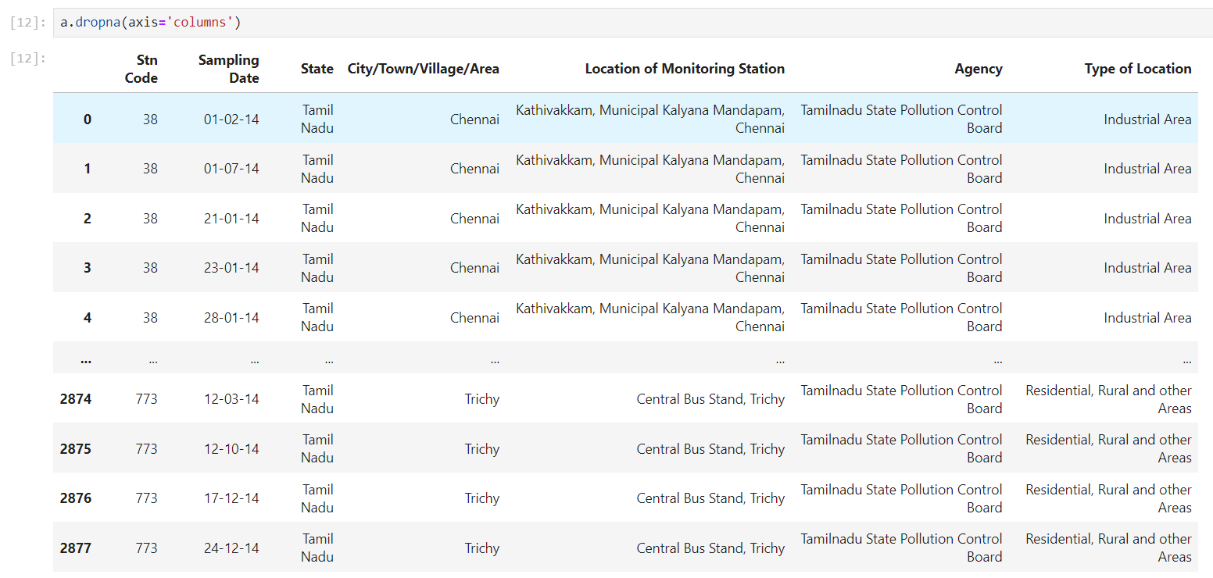

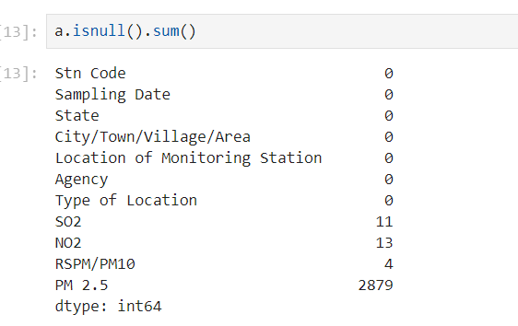

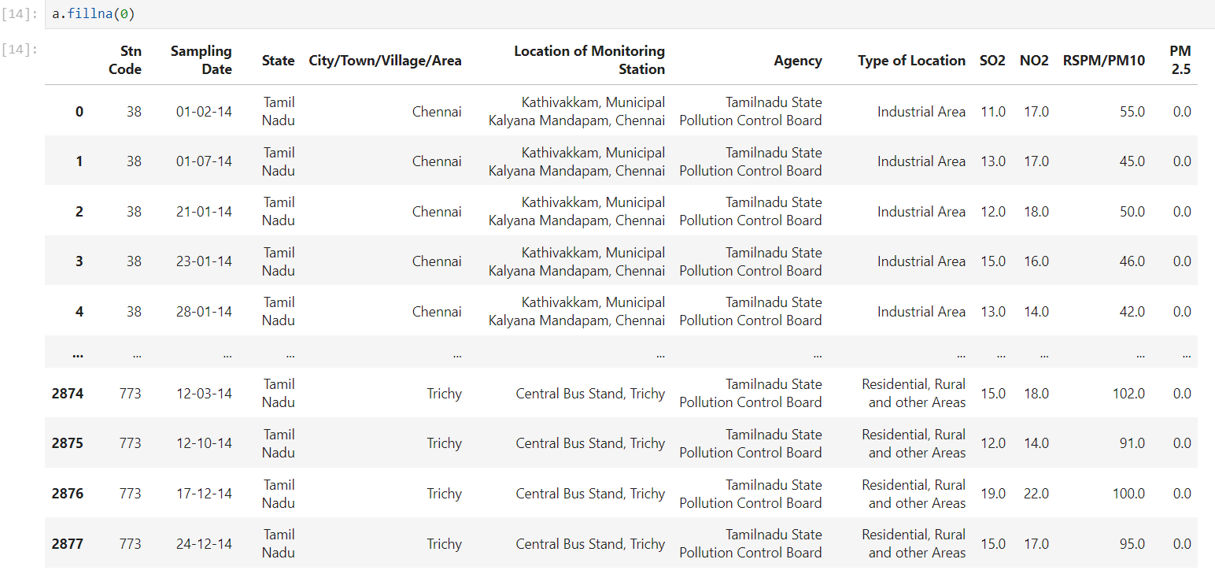

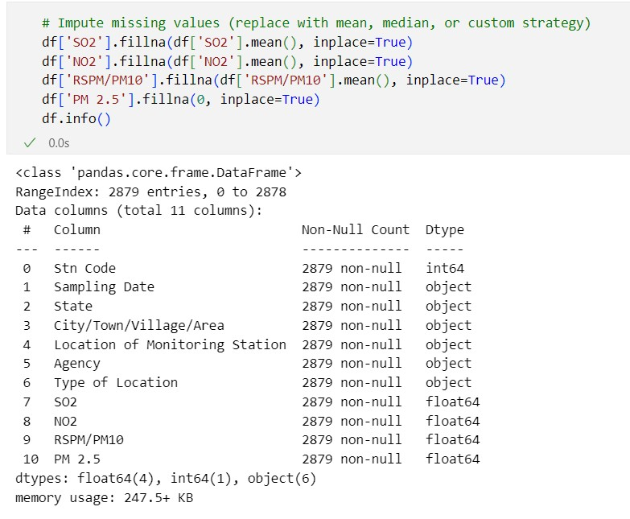

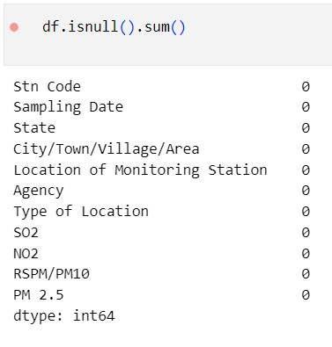

Conclusion:

The dataset has been preprocessed and visualization in the phase executed successfully.